Chapter 17, Solution 72.

T = 5, ω_{o} = 2π/T = 2π/5

f(t) is an odd function. a_{o} = 0 = a_{n}

b_{n} = 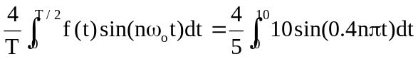

= 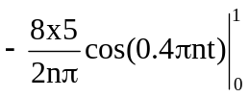 = 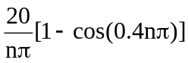

f(t) = 